2018-19 Parent Information

TUITION:
Monthly automatic draft (add $20 for a second team)
$100 Tiny/Mini
$130 Youth/Junior/Senior (Non Worlds)
$150 Worlds Teams
*tuition is drafted for the 30 day period following a written request to leave the program.

REGISTRATION FEE:
$50 for one child - $75 max per family.
Athletes who tried out at an another location- $15 individual/ $25 family
*Registration fee, May tuition and draft paperwork must be completed in order for an athlete to be placed on a team.

UNIFORMS:
Payment for uniforms will be due at fitting. Cash, Money Order, and Cashier's Check will be the only method of payment accepted. NO PERSONAL CHECKS. Estimated cost of uniform is $325-$350. Uniform for teams using a specialty uniform (Elite or Worlds team) Estimated cost is $350-$375. If you cannot make it to or miss the fittings, you will be required to attend a fitting at another location. Note: If you leave the program after you have been sized for a uniform, you will be refunded your payment minus a $75 restocking fee at the end of our season, if and only if the uniform has been sold to another athlete. You will not be given the uniform to sell.
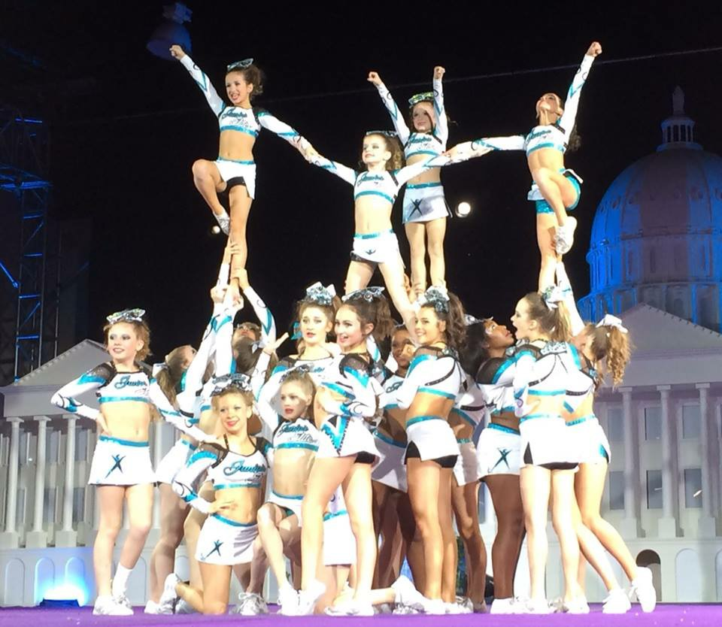
TEAM/COMPETITION FEES: (Are non-refundable)
Please plan ahead financially to meet the deadlines for the 8
Installments listed below. Any.

- All competition fees: 6-9 competitions per season. Prices vary by team
- Music fee: $100 per athlete
- Coaches Travel Fee: $150-200 per athlete. Varies by team
- Choreography Fee: $125-175 per athlete
- End of year banquet: $20 per athlete
All of the above totaled and divided into 8 installments

Competition fees $200 /month starting in July and will be reevaluated at the end of September once the competition schedule has been finalized.

**Crossover athletes will pay a one time fee of $25-$300 (depends on which teams are crossed to)

If crossing to another gym and travel to a competition that is not in your home gym competition schedule, you will be responsible for paying that competition fee.

Final Competition Schedule
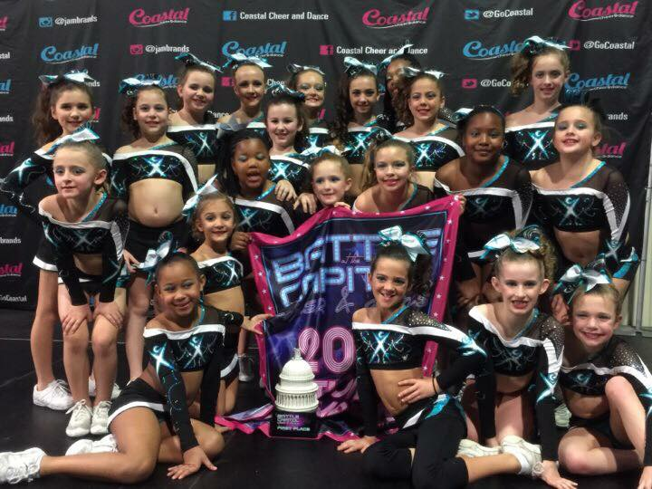
In order to be sure teams are attending the best competitions for them, the competition schedule will not be finalized until the end of August.

ADDITIONAL FEES:
Skills Camp or Beach Camp Fee-
Paid for host gym use $170 (Additional fees may apply)
Mandatory Universal Practice Outfit
Approx. $100 (check to Betsy Smith)
Mandatory Make up Kit - $40 (Check to Betsy Smith)

