2020-21 Parent Information

TRYOUT DATES:
May 16 - 17, 2020
May 19 - 21, 2020 (stunt evaluations)

TUITION:
Monthly automatic draft (add $20 for a second team)
$100 Tiny
$120 Mini
$130 All Other Youth/Junior/Senior (Non-Worlds)
$150 Worlds Teams
*tuition is drafted for the 30-day period following a written request to leave the program.

REGISTRATION FEE:
$50 for one child - $75 max per family.
Athletes who tried out at another CEA location- $15 individual/ $25 family
*Registration fee, May tuition and draft paperwork must be completed and paid in full for an athlete to be placed on a team.

UNIFORMS:
Payment for uniforms will be due at fitting. Cash, Money Order, and Cashier's Check will be the only method of payment accepted. NO PERSONAL CHECKS. Estimated cost of uniform is $325-$350. Uniform for teams using a specialty uniform (Elite or Worlds team) have an estimated cost of $350-$375. If you cannot make the scheduled fittings or miss the fittings, you will be required to attend a fitting at another location. Note: If you leave the program after you have been sized for a uniform, you will be refunded your payment minus a $75 restocking fee at the end of our season, if and only if the uniform has been sold to another athlete. You will not be given the uniform to sell.

TEAM/COMPETITION FEES: These fees are non-refundable.
Please plan ahead financially to meet the deadlines for the eight
Installments consisting of the costs listed below:

- All competition fees: 6-9 competitions per season. Prices vary by team
- Music fee: $100 per athlete
- Coaches Travel Fee: $150-200 per athlete. Varies by team
- Choreography Fee: $125-175 per athlete
- End of year banquet: $20 per athlete
All of the above totaled and divided into eight payments drafted monthly.

Competition fees @ $250 /month will be starting in July and will be re-evaluated at the end of September once the competition schedule has been finalized.
**Crossover athletes will pay a one-time fee of $250-$300 (final cost depends on which teams the athlete crosses to) If crossing to another gym and travel to a competition that is not in your home gym competition schedule, you will be responsible for paying that competition fee.
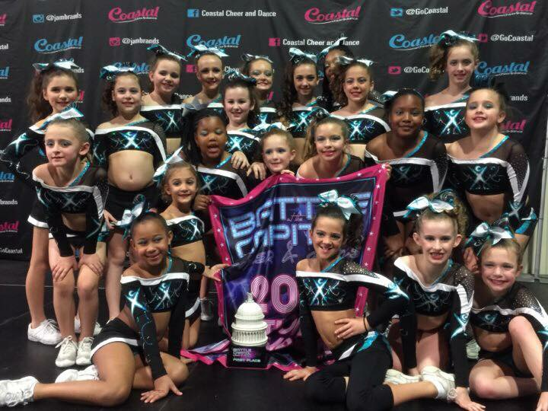
FINAL COMPETITION FEES: In order to be sure teams are attending the best competition, the competition schedule will not be finalized until the end of September 2020.
ADDITIONAL FEES:
Skills Camp or Beach Camp Fee-
Paid for host gym use $170 (Additional fees may apply)
Mandatory Universal Practice Outfit
Approx. $100 (check to Betsy Smith)
Mandatory Make up Kit - $40 (Check to Betsy Smith)

