CEA 2020 Video Tryout Requirements
Videos must include:
- Name of athlete
- Stunting Position/Level and tumbling level
- Example of stunting, flying (if you are a flier) and tumbling (both standing tumbling and tumbling pass)
- Team’s that you would like to be considered for
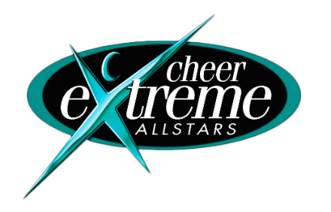
Please email videos to ceavideotryouts@gmail.com by June 6th.

